Lab 3: Beginner Assembly with the CPU Visual Simulator
Module | ET4047
Date | 27/09/2026
Lab No. | Lab 3
Author | Luke Griffin

This lab introduces assembly programming on the CPU Visual Simulator (cpuvisualsimulator.github.io). It follows the approach from the W03 lecture: first understand how the CPU and memory are organised, then write each program as pseudo code, translate it into assembler, and check it by comparing the state of the CPU before and after execution.
By the end of this lab you should be able to:
- describe what the PC, IR, Control Unit, MUX, ALU, ACC and Status Word do, and what travels on the address, data and control buses;
- explain how an instruction is stored in memory (opcode and operand) and why the PC goes up in steps of 2;
- tell the difference between immediate (#X) and direct (X) addressing and predict the result of each;
- read and write register-transfer notation such as [X] -> ACC and ACC + #1 -> ACC;
- translate IF-THEN-ELSE and WHILE-DO pseudo code into assembler using CMP and conditional jumps.

How this lab works. Part A explains how the simulator works. Read it first and keep it open as a reference. Part B contains six tasks. Each task gives the pseudo code, the assembler (a worked example), and a before/after table so that you can check your run. Load the example, run it, and confirm that you get the same result. Then complete the Your Turn exercises, which ask you to predict, modify and then write programs of your own. Write your answers in the boxes and tables provided.

Part A: How the CPU Visual Simulator Works

A1. The simulator at a glance
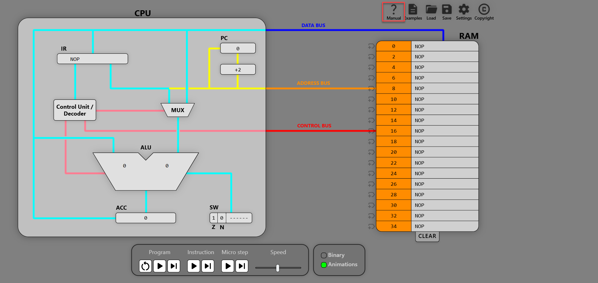
Figure 1: CPU Visual Simulator
The simulator models a simple accumulator-based CPU connected to RAM by three buses. Each part of Figure 1 is described below.
Part | What it does
PC (Program Counter) | Holds the address of the next instruction to fetch. The +2 box adds 2 after each fetch, because every instruction takes 2 bytes.
IR (Instruction Register) | Holds the instruction being executed. It is split into the opcode (what to do), which goes to the Control Unit, and the operand (an address or a number).
Control Unit / Decoder | Decodes the opcode and controls everything else (pink wires). It sets the MUX, chooses the ALU operation and sends read or write signals to RAM on the control bus.
MUX (multiplexer) | A switch that picks the ALU's second input. For immediate operands (#5) it takes the number from the IR. For direct operands (A) it takes the value read from RAM over the data bus.
ALU (Arithmetic Logic Unit) | Does the calculation. The left input is always the ACC and the right input comes from the MUX. The symbol shows the operation: +, -, *, : or = (pass the value straight through).
ACC (Accumulator) | The CPU's single working register (16 bits). Every load and every ALU result ends up here.
SW (Status Word) | Holds the flags. Z = 1 when the last ALU result was zero. N = 1 when it was negative. Conditional jumps test these flags.
RAM | Memory holding both the program and its data. The simulator shows 18 cells, at addresses 0 to 34.
Address bus (orange) | Tells RAM which address to use: the PC during a fetch, or the IR operand during execution.
Data bus (blue) | Carries the value: instructions into the IR, data to the MUX, and the ACC into RAM for STO.
Control bus (red) | Tells RAM what to do: read or write.

A2. Memory organisation
Every memory address holds 8 bits (one byte), and addresses are also 8 bits, so the address range is 0 to 255 (00000000 to 11111111). An instruction is 16 bits: an 8-bit opcode and an 8-bit operand. Each instruction therefore occupies two addresses. That is why instructions sit at even addresses (0, 2, 4 …) and why the PC adds 2 after every fetch.
Address | OPCODE | OPERAND
0 | opcode of instruction 1 | operand of instruction 1 | Instruction 1
2 | opcode of instruction 2 | operand of instruction 2 | Instruction 2
4 | opcode of instruction 3 | operand of instruction 3 | Instruction 3

A program has two parts. The instruction block starts at address 0 and ends with HLT. The data block holds the variables. Data values use the I16 format: signed 16-bit integers from −32768 to 32767. When a code file is loaded, its lines go into memory one after another, starting at address 0. To put the data block at the bottom of RAM, as the example does in the WHILE-DO example, insert NOP lines between HLT and the data. The worked tasks in Part B do this, so their variables are at addresses 30 to 34, as in the figures. The NOPs are never executed, because the CPU stops at HLT.

A3. Instruction structure and addressing modes
Each instruction has three fields. The first bit of the opcode byte is the immediate flag, which says how to interpret the operand:
Field | Bits | Meaning
Immediate flag | 1 bit (the leftmost) | 0 = direct addressing, 1 = immediate addressing
Opcode | 7 bits | Which operation to perform (LOD, ADD, JMP …)
Operand | 8 bits | Direct: an address (8 bits). Immediate: a number (I8, −128 to 127).

For example, LOD X is 00000111 and LOD #X is 10000111. The opcode is the same, and only the immediate flag differs. The two addressing modes are the most important idea in this lab:
Mode | Written as | The operand is … | Example | Meaning
Direct | LOD A | the address of the value | LOD A | [A] -> ACC: go to address A and load what is stored there
Immediate | LOD #5 | the value itself | LOD #5 | #5 -> ACC: load the number 5
Immediate with a label | LOD #A | the address of A, used as a number | LOD #A | loads the number 34 (A's address), not A's contents

- An immediate value must fit in 8 bits: −128 to 127. To use a bigger number, such as 300, store it as data and load it directly.
- A direct operand must be a valid address: an even number from 0 to 254, or a label.
- STO and the jumps only use direct addressing. You can only store into, or jump to, an address.

A4. Instruction set in register-transfer notation
The lecture describes each instruction in register-transfer notation (RTN). [X] means "the contents of memory location X", #X means "the number X", and -> means "is copied into". Use this notation in your code comments, as the example files do.
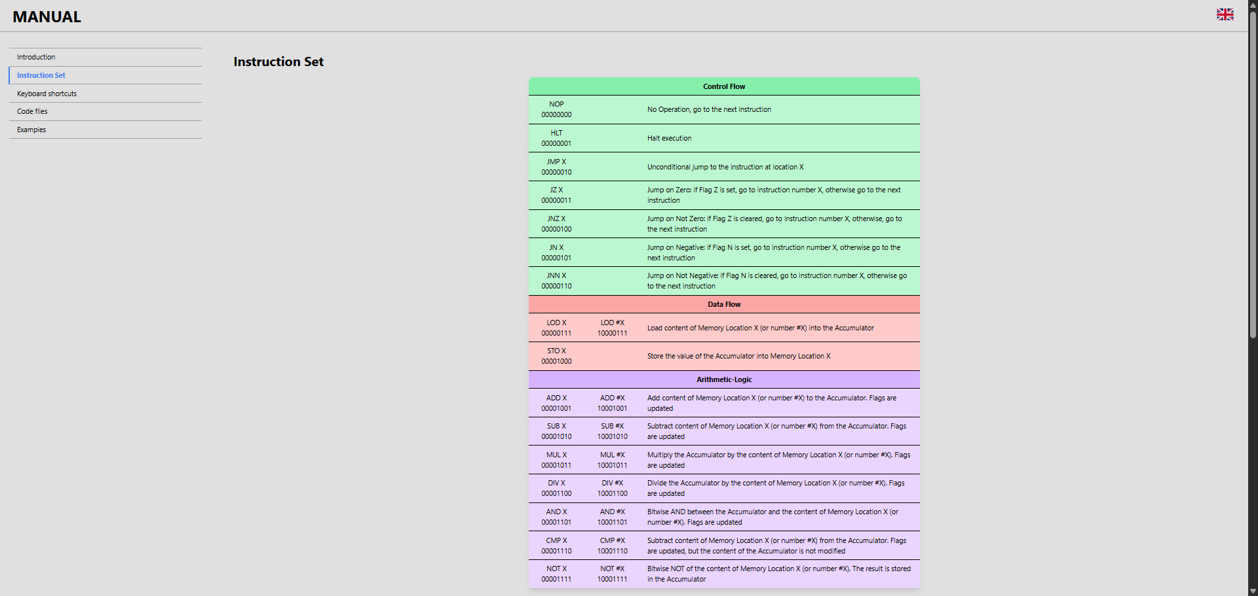
Figure 2: Instruction set (simulator Manual)
Instruction | Opcode | Direct (X) | Immediate (#X) | Flags
NOP | 0000000 | no operation
HLT | 0000001 | halt execution
JMP X | 0000010 | X -> PC
JZ X | 0000011 | if Z = 1 (ACC == 0): X -> PC |  | reads Z
JNZ X | 0000100 | if Z = 0 (ACC ≠ 0): X -> PC |  | reads Z
JN X | 0000101 | if N = 1 (ACC < 0): X -> PC |  | reads N
JNN X | 0000110 | if N = 0 (ACC ≥ 0): X -> PC |  | reads N
LOD | 0000111 | [X] -> ACC | #X -> ACC
STO X | 0001000 | ACC -> [X]
ADD | 0001001 | ACC + [X] -> ACC | ACC + #X -> ACC | updates Z, N
SUB | 0001010 | ACC - [X] -> ACC | ACC - #X -> ACC | updates Z, N
MUL | 0001011 | ACC * [X] -> ACC | ACC * #X -> ACC | updates Z, N
DIV | 0001100 | ACC / [X] -> ACC | ACC / #X -> ACC | updates Z, N
AND | 0001101 | ACC AND [X] -> ACC | ACC AND #X -> ACC | updates Z, N
CMP | 0001110 | ACC - [X] (ACC == X?) | ACC - #X (ACC == #X?) | updates Z, N only
NOT | 0001111 | NOT([X]) -> ACC | NOT(#X) -> ACC

Important: jumps test the flags, not the ACC. The flags only change when an arithmetic or logic instruction runs (ADD, SUB, MUL, DIV, AND, CMP). LOD and STO leave them alone. After a reset the ACC is 0, so Z starts at 1. After loading a value, always use CMP before a conditional jump. CMP works like SUB but only updates the flags, so the ACC keeps its value.

A5. How an instruction is executed
Every instruction goes through the same fetch–decode–execute cycle:
Stage | What happens | Bus used
Fetch | The PC's value goes on the address bus. RAM is told to read, sends the instruction back over the data bus into the IR, and the PC becomes PC + 2. | address, control, data
Decode | The Control Unit reads the opcode (and immediate flag) in the IR and sets up the MUX, the ALU and the bus signals. | internal (pink wires)
Execute | The instruction runs. It may read an operand from RAM, calculate in the ALU, write to RAM, or load a new address into the PC (jumps). | depends on the instruction

For example, here is how LOD A (direct) executes, as shown in the LOD X before/after example:
Step | What moves | Result
1 | PC (0) → address bus. Control bus: read. RAM[0] → data bus → IR | IR = LOD A, PC = 2
2 | Control Unit decodes LOD with immediate flag = 0 (direct) | MUX set to "memory"
3 | IR operand (address of A) → address bus. Control bus: read | RAM puts [A] on the data bus
4 | Data bus → MUX → ALU (operation =, pass through) → ACC | ACC = [A]

With LOD #5 (immediate), step 3 is skipped. The MUX takes the number 5 straight from the IR operand, so RAM is not read. For STO A, the ACC's value goes onto the data bus and the control bus signals write.
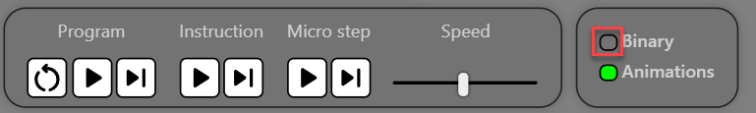
Figure 3: Control bar
The control bar has three ways to run a program. Program runs the whole program. Instruction runs one complete fetch–decode–execute cycle at a time. Micro step shows one bus transfer at a time, which is the best way to watch the steps in the tables above. Use Speed to slow the animation down. The Binary switch shows RAM and the registers in binary, so that you can see the opcode, the immediate flag and the operand.

A6. Writing programs: pseudo code, assembler and code files
One approach to writing a program is:
- 1. Write the pseudo code, for example IF (X == 3) THEN Y = Y + 5 ELSE Z = Z + 2 ENDIF.
- 2. Translate it into assembler using the IF-THEN-ELSE or WHILE-DO pattern below.
- 3. Comment every line in register-transfer notation, for example ;[X] -> ACC.
- 4. Run it and compare the before and after states (registers, flags and variables) with what you expected.
The IF-THEN-ELSE and WHILE-DO patterns
IF-THEN-ELSE | Assembler pattern | WHILE-DO | Assembler pattern
IF (condition) | LOD / CMP, then jump to ELSE if the condition is false | WHILE (condition) | WHILE: LOD / CMP, then jump to ENDWHILE if false
THEN instruction_1 | THEN: … followed by JMP ENDIF | DO instruction_2 … | loop body, followed by JMP WHILE
ELSE instruction_2 | ELSE: … | ENDWHILE | ENDWHILE: next instruction
ENDIF instruction_3 | ENDIF: …

Code files (.cpuvs)
- A .cpuvs file is a plain text file. Open it with Load and save your work with Save.
- Each line holds one instruction or one data value, and lines are stored from address 0 onwards.
- The format is LABEL: INSTRUCTION. The label is optional; when you leave it out, leave out the : too.
- Everything after ; is a comment. Empty lines and comment-only lines are ignored.
- If the file has an error, the simulator shows a message along its top edge.
Figure 4 shows IF_THEN_ELSE_example.cpuvs, which you will use in Task 4.
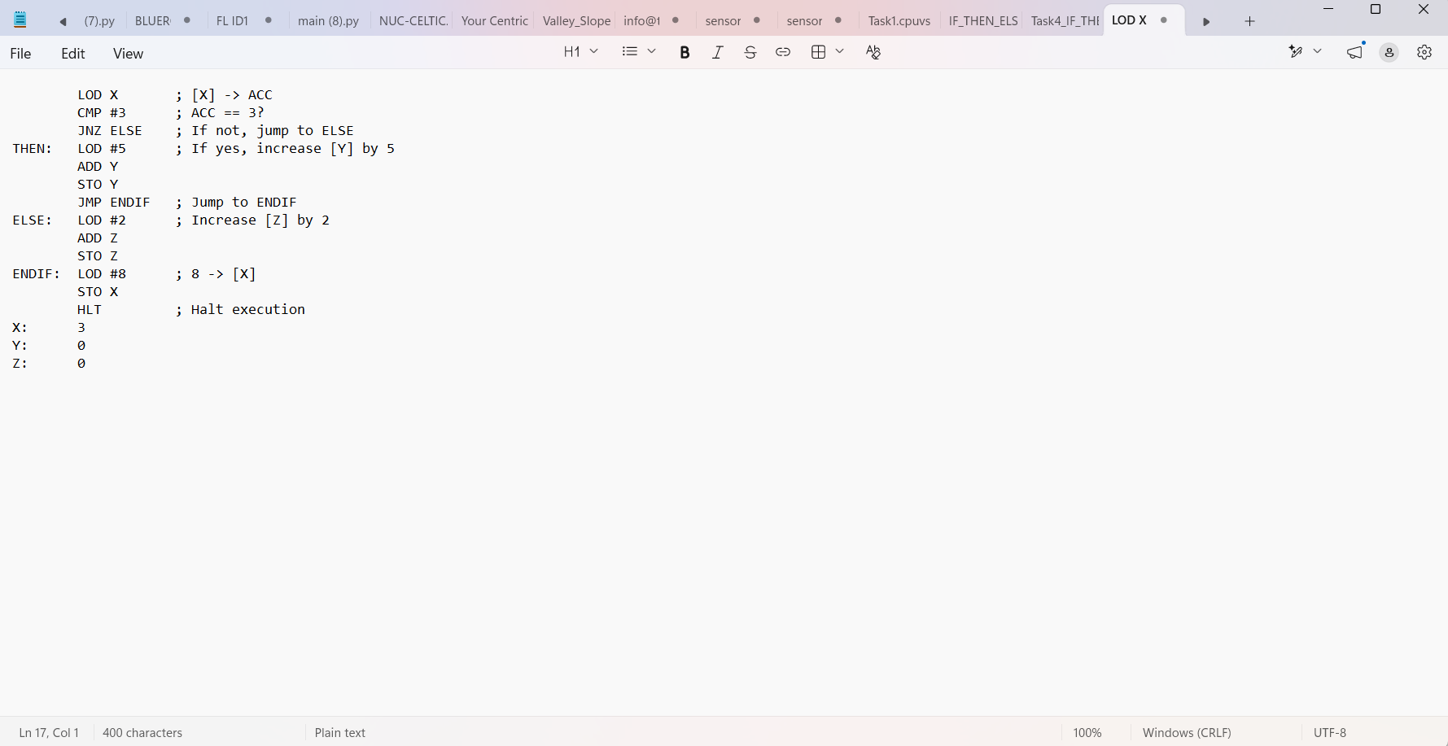
Figure 4: Example code file (IF-THEN-ELSE example)

Part B: Lab Tasks
Each worked example below is written the same way. There is a ; comment in register-transfer notation on each line, the instruction block starts at address 0, and the data block is padded to the bottom of RAM with NOP so that the addresses match the figures. For your own programs you can leave out the NOP padding. The data then goes straight after HLT, as in the IF-THEN-ELSE example.

Task 1: Load and Store (Immediate and Direct Addressing)
Goal: Put a value into memory and read it back. This task shows the difference between immediate addressing (#5 is the number 5) and direct addressing (A is an address in memory).
Pseudo code
A = 5
ACC = A
Assembler
LOD #5 ; #5 -> ACC (immediate: the number 5)
STO A ; ACC -> [A] (direct: store at address A)
LOD A ; [A] -> ACC (direct: load from address A)
HLT ; Halt execution
NOP
NOP
NOP
NOP
NOP
NOP
NOP
NOP
NOP
NOP
NOP
NOP
NOP
A: 0 ; Data block: A is at address 34
LOD #5 uses immediate addressing: the operand byte holds the number 5 itself, so RAM is not read. STO A and LOD A use direct addressing: the operand byte holds the address of A (34), and the CPU goes to that address.
Before and after execution
 | Before execution | After execution
PC | 0 | 6 (address of HLT)
ACC | 0 | 5
Z N | 1 0 | 1 0 (unchanged: LOD and STO do not update the flags)
A (address 34) | 0 | 5

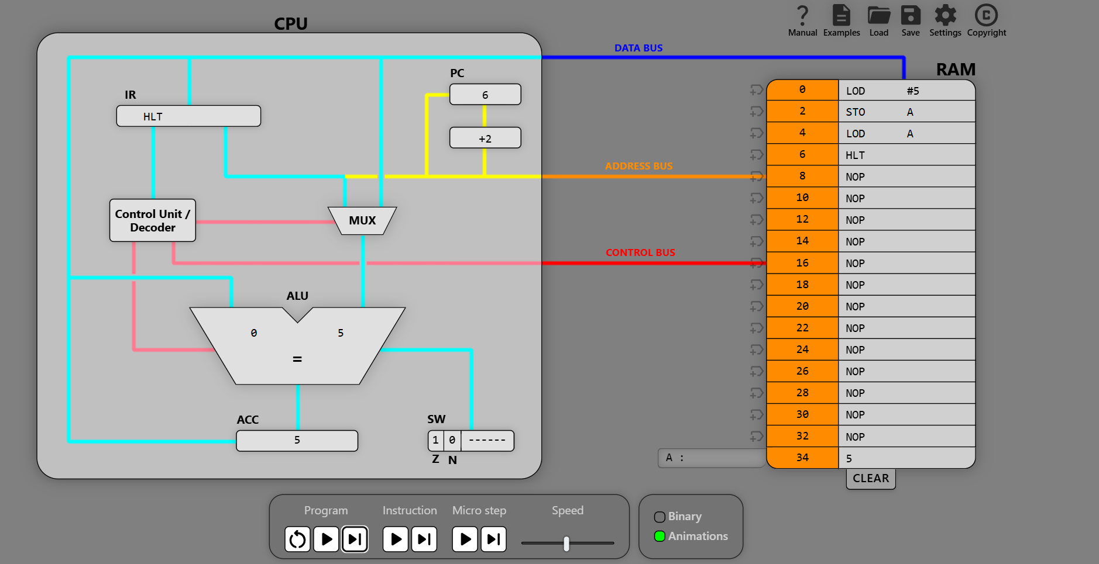
Figure 5: Task 1 after execution

Your Turn
1.1 When the program halts, the PC shows 6. Explain why the PC counts 0, 2, 4, 6 and not 0, 1, 2, 3.
Your answer:

1.2 Immediate or direct? Replace line 3 (LOD A) with each instruction below, one at a time. Predict the ACC first, then run the program to check.
Line 3 becomes | Addressing mode | Predicted ACC | Actual ACC
LOD A
LOD 34
LOD #34
LOD #A

1.3 Turn on the Binary switch. Write down the two bytes stored at address 0 (LOD #5) and at address 4 (LOD A). Which bit is different, and why?
Address | Instruction | Opcode byte | Operand byte
0 | LOD #5
4 | LOD A

Your answer:

1.4 Change the program so that it also stores the value 9 in a second variable B. Take a screenshot showing A = 5 and B = 9 in RAM.
Your code:

1.5 Write a program that swaps two variables, starting with A: 3 and B: 8. When it halts, A should be 8 and B should be 3.
Hint: The ACC can only hold one value at a time, so you will need a third variable (TEMP) to keep one value safe.
Your code:

Task 2: Arithmetic and Expressions
Goal: Use the ALU to do arithmetic with values from memory (direct) and constants (immediate), and store the results back in RAM.
Part 1: adding two numbers from memory
SUM = A + B
LOD A ; [A] -> ACC
ADD B ; ACC + [B] -> ACC
STO SUM ; ACC -> [SUM]
HLT ; Halt execution
NOP
NOP
NOP
NOP
NOP
NOP
NOP
NOP
NOP
NOP
NOP
A: 3 ; address 30
B: 4 ; address 32
SUM: 0 ; address 34 (7 after execution)
 | Before execution | After execution
PC | 0 | 6
ACC | 0 | 7
Z N | 1 0 | 0 0 (ADD updated the flags: 7 is not zero and not negative)
A, B (addresses 30, 32) | 3, 4 | 3, 4 (unchanged)
SUM (address 34) | 0 | 7

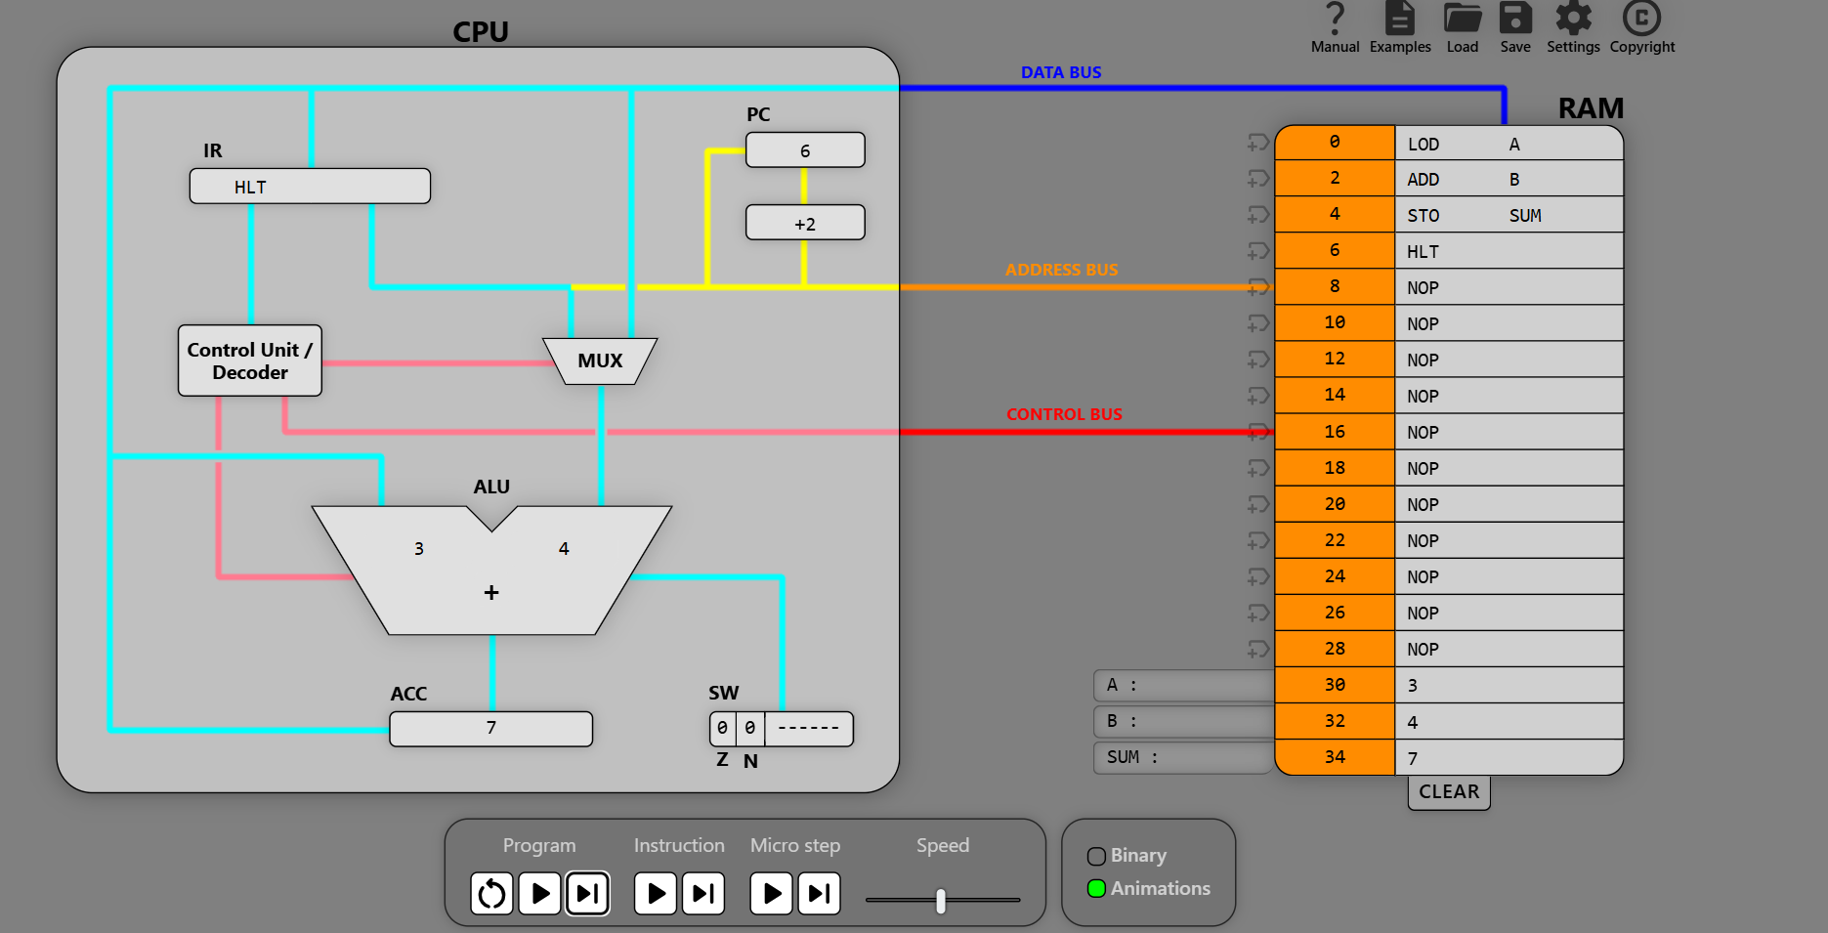
Figure 6: Task 2 after execution
Part 2: evaluating an expression (Example 1)
To calculate a longer expression, split it into parts. Work out each part in the ACC and store it in a variable, then combine the parts. Most operands here are immediate constants. MUL X is direct, because it uses the value stored in X.
X = 3 + 4*5
Y = 2*3 - 1
W = X * Y * 2
; Calculate expression: W = (3+4*5)*(2*3-1)*2
; X = 3+4*5
; Y = 2*3-1
; W = X*Y*2
LOD #4 ; Find X = 3+4*5
MUL #5
ADD #3
STO X
LOD #2 ; Find Y = 2*3-1
MUL #3
SUB #1
STO Y
MUL X ; Find X*Y
MUL #2 ; Find X*Y*2
STO W ; Save result to W
HLT
X: 0
Y: 0
W: 0
 | Before execution | After execution
PC | 0 | 22
X, Y, W (addresses 24, 26, 28) | 0, 0, 0 | 23, 5, 230
ACC | 0 | 230

Your Turn
2.1 In Part 1, change ADD B to SUB B. Before running it, predict SUM. Then run it. What do the Z and N flags show, and why?
Your answer:

2.2 Step through Example 1 one instruction at a time and fill in the ACC after each instruction.
Instruction | ACC after | Instruction | ACC after
LOD #4 |  | MUL #3
MUL #5 |  | SUB #1
ADD #3 |  | STO Y
STO X |  | MUL X
LOD #2 |  | MUL #2

2.3 Write a program that calculates W = (3 + 4*5) * (8/4 − 1) * 4. Work out the answer by hand first.
Your code and hand calculation:

2.4 Write a program that stores the average of A: 4, B: 7 and C: 10 in AVG. Then change C to 11 and run it again. What result do you get, and why?
Your code and answer:

2.5 Why can you not write LOD #300? Give two different ways of getting the value 300 into the ACC.
Hint: Look at the size of an immediate operand in section A3, and compare it with the size of a data value.
Your answer:

Task 3: IF-THEN-ELSE (Check for Zero)
Goal: Make a decision. The program tests a value and sets FLAG depending on whether that value is zero. It uses CMP to set the flags and JNZ to choose which block runs.
Pseudo code
IF (X == 0)
THEN
FLAG = 1
ELSE
FLAG = 0
ENDIF
Assembler
LOD X ; [X] -> ACC
CMP #0 ; ACC == 0? (sets Z if yes)
JNZ NOTZERO ; If not, jump to NOTZERO
ZERO: LOD #1 ; THEN: #1 -> ACC
STO FLAG ; ACC -> [FLAG]
JMP END ; Jump to END
NOTZERO: LOD #0 ; ELSE: #0 -> ACC
STO FLAG ; ACC -> [FLAG]
END: HLT ; Halt execution
NOP
NOP
NOP
NOP
NOP
NOP
NOP
X: 0 ; address 32 (test value)
FLAG: 0 ; address 34
How it works: CMP #0 works out ACC − 0 without changing the ACC and updates the flags. If X is zero, Z is set to 1. JNZ NOTZERO jumps only when Z = 0 (X not zero), so it skips the THEN block. If X is zero, the jump is not taken. The CPU runs the THEN block from the label ZERO, and JMP END then jumps over the ELSE block. Compare this with the IF-THEN-ELSE pattern in section A6.
Before and after execution (X = 0)
 | Before execution | After execution
PC | 0 | 16 (address of HLT)
ACC | 0 | 1
Z N | 1 0 | 1 0 (set by CMP #0, because X = 0)
X (address 32) | 0 | 0
FLAG (address 34) | 0 | 1

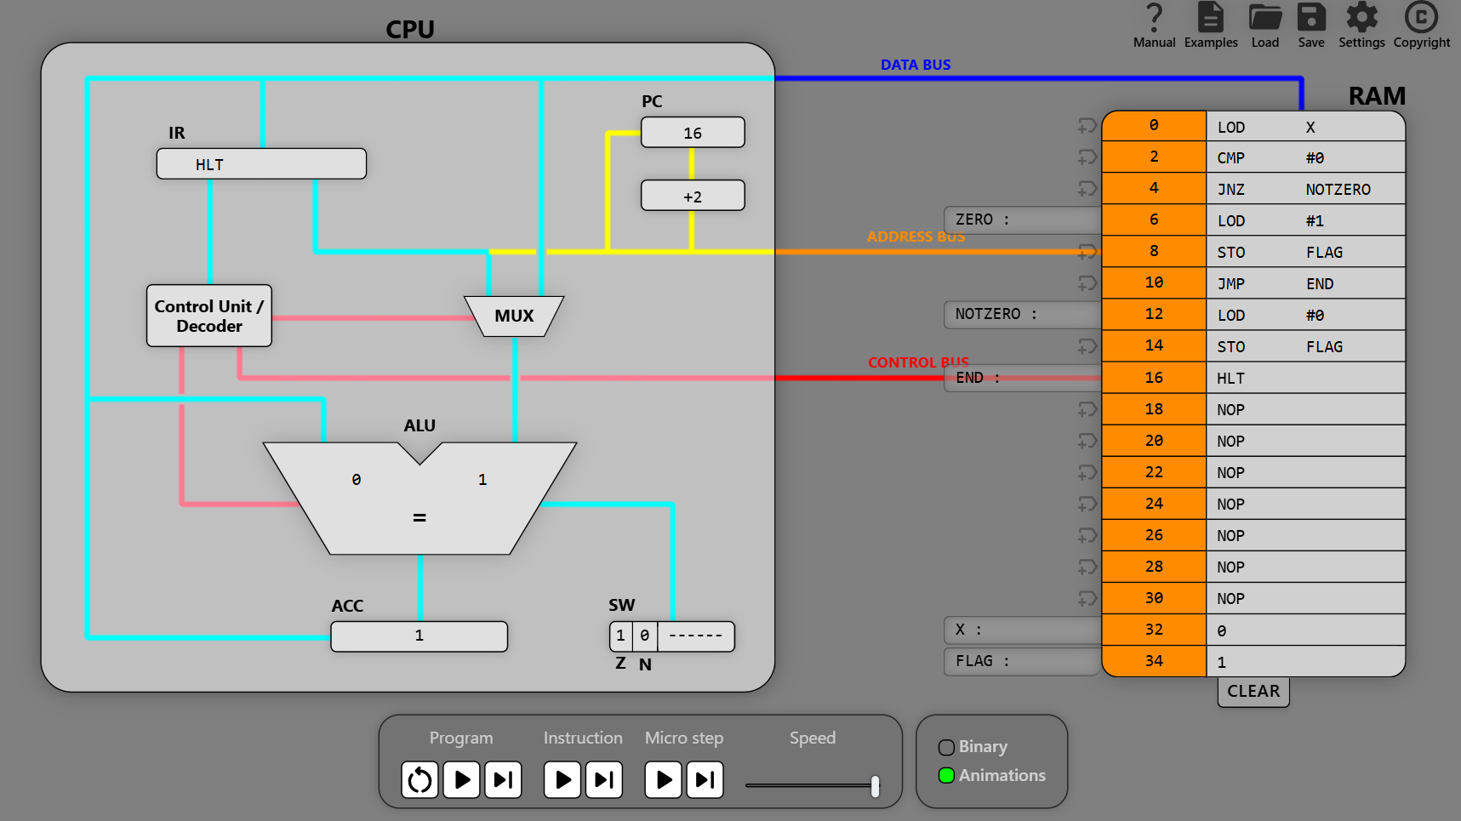
Figure 7: Task 3 after execution (X = 0)

Your Turn
3.1 Change X to 5 and step through the program one instruction at a time. What is in FLAG at the end? Which instruction addresses were skipped? Take a screenshot.
Your answer:

3.2 Rewrite the program using JZ instead of JNZ. It must give the same FLAG value for X = 0 and X = 5.
Your code:

3.3 Write a program for: IF (X < 10) THEN SMALL = 1 ELSE SMALL = 0. Test it with X = 7, X = 10 and X = 12.
Hint: CMP #10 works out X − 10. The result is negative (N = 1) exactly when X < 10. Use JN or JNN.
Your code and test results:

Task 4: IF-THEN-ELSE (Comparing Two Values)
Goal: Compare two values stored in memory. This time CMP B uses direct addressing, so the ACC is compared with the contents of B.
Pseudo code
IF (A == B)
THEN
RESULT = 1
ELSE
RESULT = 2
ENDIF
Assembler
LOD A ; [A] -> ACC
CMP B ; ACC == [B]?
JNZ NOTEQ ; If not, jump to NOTEQ
LOD #1 ; THEN: #1 -> ACC
STO RESULT ; ACC -> [RESULT]
JMP END ; Jump to END
NOTEQ: LOD #2 ; ELSE: #2 -> ACC
STO RESULT ; ACC -> [RESULT]
END: HLT ; Halt execution
NOP
NOP
NOP
NOP
NOP
NOP
A: 4 ; address 30
B: 4 ; address 32 (try changing)
RESULT: 0 ; address 34
Before and after execution (A = B = 4)
 | Before execution | After execution
PC | 0 | 16
ACC | 0 | 1
Z N | 1 0 | 1 0 (CMP B: 4 − 4 = 0)
RESULT (address 34) | 0 | 1

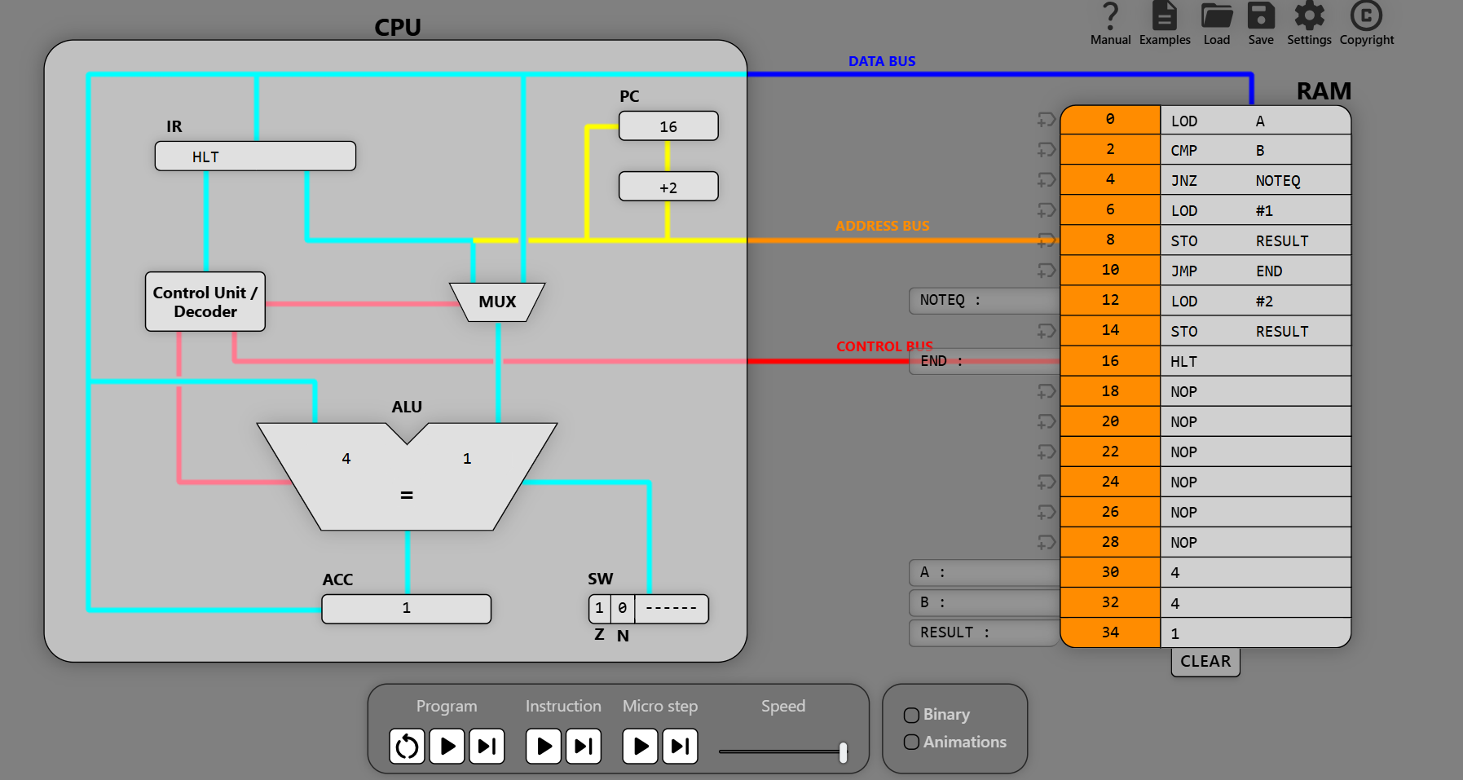
Figure 8: Task 4 after execution (A = B = 4)
Note: JMP END ends the THEN block by jumping over the ELSE block, so only one of the two blocks ever runs.

Your Turn
4.1 Change B to 3. Predict RESULT and the Z flag, then run the program to check. Take a screenshot.
Your answer:

4.2 What would happen if you deleted the JMP END line? Try it with A = B = 4 and explain what you see.
Your answer:

4.3 Load the IF_THEN_ELSE_example.cpuvs (Figure 4). Write its pseudo code, then fill in X, Y and Z after execution for the two starting values of X below.
Starting X | Which block runs? | X after | Y after | Z after
3
5

4.4 Write a program for: IF (A < B) THEN MAX = B ELSE MAX = A. Test it with A = 4, B = 9 and with A = 9, B = 4.
Hint: After CMP B, the ACC still holds A. Only the flags have changed.
Your code:

Task 5: Loops (Countdown and WHILE-DO)
Goal: Repeat instructions by jumping backwards. A loop needs a counter, a test and a backwards jump. Watch the PC. When the jump is taken, the PC is loaded with the address of the loop label.
Part 1: countdown (the test is at the bottom of the loop)
REPEAT
N = N - 1
UNTIL (N == 0)
LOD N ; [N] -> ACC
LOOP: SUB #1 ; ACC - #1 -> ACC
STO N ; ACC -> [N]
CMP #0 ; ACC == 0?
JNZ LOOP ; If not, jump back to LOOP
HLT ; Halt execution
NOP
NOP
NOP
NOP
NOP
NOP
NOP
NOP
NOP
NOP
NOP
N: 6 ; address 34 (0 after execution)
 | Before execution | After execution
PC | 0 | 10
ACC | 0 | 0
Z N | 1 0 | 1 0
N (address 34) | 6 | 0

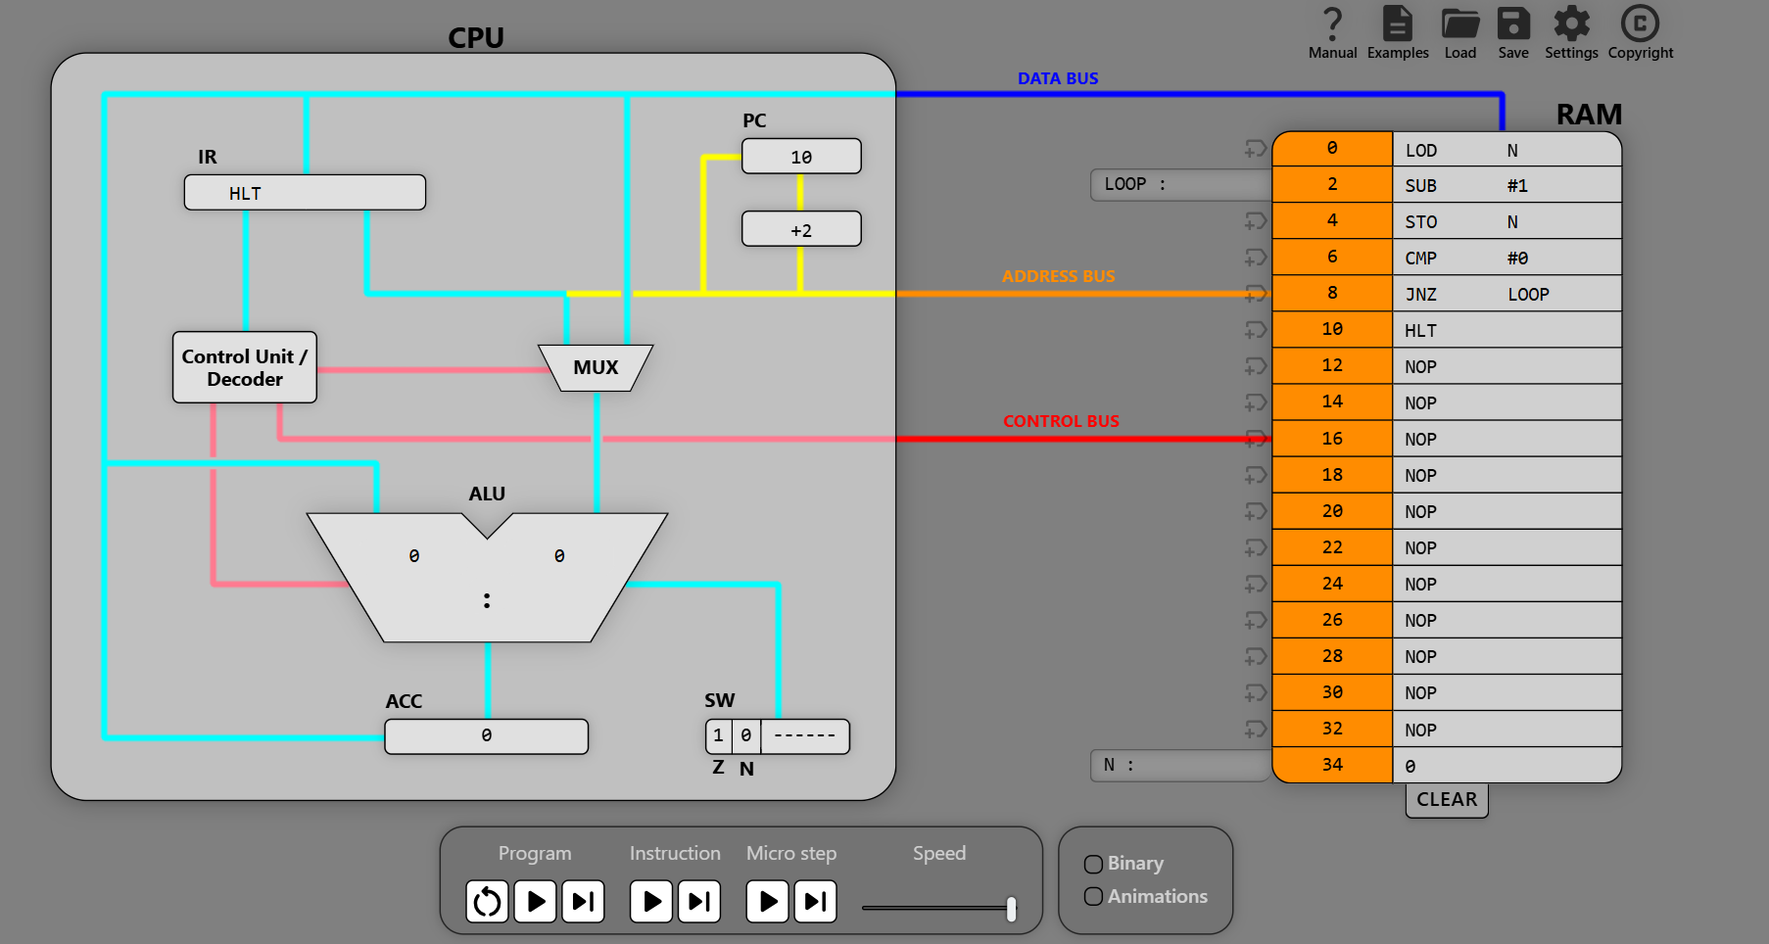
Figure 9: Task 5 after execution
Part 2: WHILE-DO (the test is at the top of the loop, from the WHILE_DO_example.cpuvs)
In a WHILE-DO loop the condition is tested before the body runs, so the body may run zero times. The three NOP lines push the data block down to addresses 30 to 34.
SUM = 0
COUNT = 0
WHILE (COUNT != MAX)
DO
COUNT = COUNT + 1
SUM = SUM + COUNT
ENDWHILE
LOD #0 ; 0 -> ACC
STO SUM ; 0 -> [SUM]
STO COUNT ; 0 -> [COUNT]
WHILE: LOD COUNT ; [COUNT] -> ACC
CMP MAX ; ACC == [MAX]?
JZ ENDWHILE ; If yes, jump to ENDWHILE
ADD #1 ; ACC + 1 -> ACC
STO COUNT ; ACC -> [COUNT] (COUNT++)
ADD SUM ; ACC + [SUM] -> ACC
STO SUM ; ACC -> [SUM]
JMP WHILE ; Jump to WHILE
ENDWHILE: HLT ; Halt execution
NOP
NOP
NOP
MAX: 3
COUNT: 0
SUM: 0
 | Before execution | After execution
PC | 0 | 22 (ENDWHILE)
MAX, COUNT, SUM (addresses 30, 32, 34) | 3, 0, 0 | 3, 3, 6

Your Turn
5.1 In Part 1, how many times does SUB #1 run when N = 6? When JNZ LOOP jumps, what value is loaded into the PC?
Your answer:

5.2 In Part 1, set N: 0 and run the program at a slow speed. What happens, and why? Fix the program by rewriting it as a WHILE-DO loop (test first), so that it halts straight away when N = 0 and still counts down when N = 6.
Your explanation and fixed code:

5.3 Step through Part 2 and fill in COUNT and SUM at the end of each pass through the loop. Then predict SUM for MAX = 5 and check it.
Pass | COUNT | SUM
1
2
3
SUM for MAX = 5 (predicted / actual)

5.4 Part 2 uses JZ ENDWHILE, but Part 1 uses JNZ LOOP. Explain why each loop needs a different jump.
Your answer:

Task 6: Bitwise Logic (NOT and AND)
Goal: Use the logic instructions. NOT flips all 16 bits of a value, and AND combines two values bit by bit. In I16 format, 0 is 0000000000000000 and −1 is 1111111111111111 (two's complement), so 0 and −1 can be used as FALSE and TRUE.
Pseudo code
X = NOT A
Y = NOT B
Z = X AND Y
W = NOT Z
Assembler
NOT A ; NOT([A]) -> ACC
STO X ; ACC -> [X]
NOT B ; NOT([B]) -> ACC
STO Y ; ACC -> [Y]
LOD X ; [X] -> ACC
AND Y ; ACC AND [Y] -> ACC
STO Z ; ACC -> [Z]
NOT Z ; NOT([Z]) -> ACC
STO W ; ACC -> [W]
HLT
A: 0
B: 0
X: 0
Y: 0
Z: 0
W: 0
NOT A uses direct addressing, so the CPU loads [A], inverts every bit and puts the result in the ACC. No separate LOD is needed. There is no NOP padding here, so the data block starts straight after HLT at address 20.
Before and after execution (A = 0, B = 0)
 | Before execution | After execution
PC | 0 | 18
X, Y, Z (addresses 24, 26, 28) | 0, 0, 0 | −1, −1, −1
W (address 30) | 0 | 0

Your Turn
6.1 Run the program for every combination of A and B below and fill in W.
A | B | W | A | B | W
0 | 0 |  | −1 | 0
0 | −1 |  | −1 | −1

6.2 Which logic gate does this program implement? Use De Morgan's law to explain why. Predict W for A = 5 and B = 3, and check it (hint: write 5 and 3 in binary).
Your answer:

6.3 Write a program that calculates W = NOT(A AND B) (a NAND gate). Test it with A = B = −1.
Your code:

Challenges (Optional)
C.1 Division without DIV. Translate this pseudo code into assembler. Use JN to test R < B. Test it with A = 17 and B = 5; you should get Q = 3 and R = 2.
Q = 0
R = A
WHILE (R >= B)
DO
R = R - B
Q = Q + 1
ENDWHILE
Your code:

C.2 Write a program that calculates the factorial of N and stores it in RES (N = 5 gives 120). What goes wrong if N starts at 1, and how would you fix it?
Your code and answer:

Review Questions
R1 Explain the difference between LOD 34, LOD #34 and LOD A (where A is at address 34).
Your answer:

R2 CMP and SUB both subtract. What is the difference, and why is CMP the right choice before a conditional jump?
Your answer:

R3 Which register changes when a jump is taken? Explain how this makes loops possible.
Your answer:

R4 Which instructions update the Z and N flags? Why do the programs in this lab use CMP straight after LOD?
Your answer:

R5 An immediate operand is limited to −128 to 127, but a data value can be up to 32767. Why? (Use section A3.)
Your answer:

